**A PRELIMENERY REPORT ON**

**PIZZA DELIVERY APP**



SUBMITTED TO THE VISHWAKARMA INSTITUTE OF INFORMATION TECHNOLOGY, PUNE

IN THE PARTIAL FULFILLMENT OF THE REQUIREMENTS

FOR THE AWARD OF THE DEGREE

OF

**BACHELOR OF TECHNOLOGY (COMPUTER ENGINEERING)**

##### **SUBMITTED BY**

| **SR.NO** | **NAME** | **PRN NO.** |
| --- | --- | --- |
| 1. | YUGANDHAR PATIL | 22110256 |
| 2. | NAMAN GATPALLI | 22110337 |
| 3. | SAMEEKSHA HEDAU | 22110353 |
| 4. | PRAJWAL MAHAJAN | 22110401 |
| 5. | HARSHAL PATIL | 22110409 |

## **DEPARTMENT OF COMPUTER ENGINEERING**

**BRACT’S**

**VISHWAKARMA INSTITUTE OF INFORMATION TECHNOLOGY**

SURVEY NO. 3/4, KONDHWA (BUDRUK), PUNE – 411048, MAHARASHTRA (INDIA).

## **INDEX**

| **Sr. No.** | | | | **Title of Chapter** | **Page No.** |
| --- | --- | --- | --- | --- | --- |
| **01** | | | | **Introduction** | 3-7 |
|  | 1.1 | | | Overview | 3 |
|  | 1.2 | | | Motivation | 4 |
|  | 1.3 | | | Problem Definition and Objectives | 5 |
|  | 1.4 | | | Project Scope & Limitations | 6 |
|  | 1.5 | | | Methodologies of Problem solving | 7 |
| **02** | | | | **Literature Survey** | 8 |
| **03** | | | | **System Design** | 9-10 |
|  | | 3.1 | | System Architecture | 9 |
| **04** | | | | **Project Implementation** | 10-11 |
|  | | | 4.1 | Overview of Project Modules | 10 |
|  | | | 4.2 | Tools and Technologies Used | 11 |
| **05** | | | | **Results** | 12-17 |
|  | | | 5.1 | Outcomes | 12-14 |
|  | | | 5.2 | Screen Shots | 15-17 |
| **06** | | | | **Conclusions** | 18-20 |
|  | | 9.1 | | Conclusions | 18 |
|  | | 9.2 | | Future Work | 19 |
|  | | 9.3 | | Applications | 20 |

**1.Introduction**

* 1. **Overview**

This project concentrated on the development of a seamless and highly efficient pizza delivery app, meticulously designed to streamline the ordering process and enhance user convenience. The app's core focus is to offer customers a secure and reliable platform for ordering pizzas and processing payments. By leveraging modern, cutting-edge technologies such as Flutter, the app ensures compatibility across multiple platforms, creating a consistent and smooth user experience for individuals using different devices and operating systems. Additionally, the integration of the Razorpay API facilitates robust and secure payment transactions, offering a variety of options for users to choose from and ensuring their financial data is protected throughout the process.

Overall, the project's commitment to incorporating advanced technologies and personalized features ensures a smooth, secure, and user-friendly pizza ordering experience that stands out in a competitive market.

* 1. **Motivation**

The project was primarily driven by the desire to tackle the prevalent challenges identified in current pizza delivery apps available on the market. These challenges encompass a variety of issues such as inefficient and cumbersome ordering processes, which can be frustrating and time-consuming for users. Additionally, the existing apps often lack a seamless, integrated approach to payment gateways, leading to potential security concerns and inconveniences during the transaction process.

Furthermore, another key concern was the limited level of personalization offered to users, which restricts the overall user experience and fails to cater to the diverse tastes and preferences of individual customers. This project aims to rectify these shortcomings by developing an app that prioritizes an intuitive and smooth user experience. It seeks to streamline the ordering process for quick and easy navigation, provide secure and reliable transactions through advanced payment integrations. Through these enhancements, the app aspires to offer a superior, user-centered approach to pizza delivery that sets a new standard for convenience and satisfaction.

* 1. **problem definition and objectives**

The primary issues that this project aims to resolve are multifaceted, encompassing several significant areas of concern. Firstly, there is a focus on enhancing the overall ease and efficiency of the pizza ordering process, which involves streamlining the user experience to make ordering quick, intuitive, and straightforward. Another major aspect is the incorporation of a secure and reliable payment gateway that facilitates smooth transactions while maintaining the highest standards of security and user data protection.

The project outlined several key objectives to achieve its goals:

These include the development of a user-friendly interface that simplifies the pizza ordering process, making it more accessible and enjoyable for users of all skill levels. Another crucial objective is the seamless integration of the Razorpay API, ensuring secure, efficient, and user-friendly payment processing across various payment methods. thereby enhancing the overall user experience and satisfaction with the app.

* 1. **Project Scope and limitations**

The scope of this project is centered around the development of a comprehensive pizza delivery application that incorporates a wide range of essential features. These features include secure and efficient authentication processes for user access and account management. Additionally, the app integrates secure payment solutions, providing users with a variety of trusted payment options for transactions.

However, the project also encountered some limitations. One notable limitation was the restricted geographic scope in the early stages, as the app was tailored for a specific region. Despite this, there are plans for future expansion as the app evolves and gains popularity. Another potential challenge is related to compatibility issues that may arise when operating across different devices and operating systems. streamlined pizza selection options that allow users to browse and customize their orders with ease, and a seamless ordering process that ensures a quick and hassle-free experience from selection to checkout. This includes ensuring a consistent and high-quality experience for all users, regardless of the technology they use.

* 1. **Methodologies of Problem solving**

The development process for this project adopted an agile approach, which is characterized by its flexibility and iterative progress. This methodology allowed the development team to continuously refine and enhance the app through multiple cycles of planning, execution, and review. By breaking the project down into manageable phases and sprints, the team was able to implement small, incremental improvements and adapt quickly based on the results of each iteration.

A critical component of the agile approach was the consistent and ongoing collection of user feedback. Throughout the development process, input from users was actively sought and meticulously analyzed to gain insights into their experiences, preferences, and potential pain points. This user-centered feedback was then leveraged to fine-tune the app's features and overall experience, ensuring that the end product closely aligned with users' needs and expectations.

Furthermore, rigorous testing and quality assurance measures were applied at various stages of development to uphold the app's quality and functionality. A comprehensive suite of testing methodologies, including unit testing, integration testing, and user acceptance testing, was employed to meticulously evaluate the app's performance and identify any issues. This thorough testing approach not only validated the app's stability and security but also ensured that the final product delivered a seamless and satisfying user experience.

**2. Literature Survey**

**Analysis of Existing Solutions:**

A thorough examination of the current landscape of pizza delivery apps on the market provided valuable insights into existing products and services. This analysis highlighted both strengths and weaknesses in current offerings, revealing potential areas for enhancement and innovation. By identifying common pain points and gaps in user experience across competing apps, the team gained a clear understanding of what improvements were needed to set their app apart and offer a superior service.

**Research on Payment Gateways:**

An in-depth investigation into various available payment gateways was conducted to find the most suitable option for secure, efficient, and reliable payment processing within the app. This research led to the careful selection of the Razorpay API, which was chosen due to its proven capabilities in providing robust security features, fast and seamless transactions, and support for multiple payment methods. This decision ensured that users would benefit from smooth and safe payment experiences when ordering through the app.

**3.System Design**

**3.1 System Architecture**

**User Authentication:** The application incorporates a robust and secure user authentication module, providing multiple options for users to access their accounts and maintain their privacy. This includes the standard method of email and password-based login, allowing users to create and manage their accounts securely. Additionally, the app supports authentication through popular social media platforms, offering users convenient and efficient login options without compromising security. This multifaceted approach ensures that users can choose the authentication method that best suits their preferences and needs.

**Pizza Selection and Ordering:** The app's user interface is designed with a focus on simplicity and intuitiveness, providing an enjoyable experience for customers as they navigate through the pizza selection and ordering process. Users can easily browse through the available pizza options, with clear descriptions and images to aid their decision-making. The app also allows for customization, enabling users to personalize their orders with preferred toppings, sizes, and other special requests. This streamlined process ensures that placing orders is quick and hassle-free for customers.

**Payment Processing:** The integration of the Razorpay API allows the app to offer a seamless and secure payment processing experience for users. This sophisticated payment gateway supports a wide variety of methods, including credit and debit cards, UPI, and digital wallets, catering to the diverse payment preferences of users. The secure and efficient handling of transactions not only enhances user trust but also contributes to an overall positive experience when completing orders.

**Backend Infrastructure:** A powerful and resilient backend server forms the backbone of the app's operational efficiency, ensuring that the application functions smoothly and effectively. This robust infrastructure handles all data storage, processing, and retrieval needs, supporting the app's various features and functions by efficiently managing data and transactions.

**4. Project Implementation**

**4.1 Overview of Project Modules**

**Authentication and Login:** The app integrates robust authentication and login modules, which are designed to offer a seamless and secure experience for users. These modules enable users to register new accounts effortlessly, verify their identity through email or phone, and set up their secure login credentials. Existing users can log in quickly using either traditional methods such as email and password or alternative methods such as social media logins. Additionally, the app provides options for managing account details, such as updating personal information, changing passwords, and recovering accounts in case of forgotten credentials.

**Pizza Selection and Ordering:** The pizza selection and ordering module is crafted to offer users an interactive and user-friendly experience when browsing and ordering. The app features a visually appealing layout, complete with high-quality images and detailed descriptions of available pizzas and menu items. Users can explore a variety of options, filter selections based on preferences or dietary restrictions, and easily customize their orders by adding or removing toppings, selecting crust types, or choosing portion sizes. The app also includes helpful tools such as a cart and order summary to allow users to review and modify their orders before proceeding to checkout.

**Payment Processing:** Integration of the Razorpay API ensures users can complete their transactions with confidence, benefiting from a range of secure and convenient payment methods. Users can choose from various options, such as credit and debit cards, UPI, net banking, and digital wallets, providing flexibility in payment choices. The app's payment processing system is designed for efficiency, enabling quick and straightforward transactions while adhering to the highest security standards to protect users' financial data. Additionally, the app offers real-time transaction notifications and order confirmations, keeping users informed throughout the payment and ordering process.

**4.2 Tools and Technologies Used**

Flutter: The app development team chose Flutter as the primary framework for building the pizza delivery application due to its cross-platform capabilities and ability to deliver a consistent and high-quality user experience across multiple operating systems and devices. By using Flutter, the app can maintain a cohesive look and feel, ensuring that users enjoy a seamless experience whether they are using iOS, Android, or even a web interface. Flutter's expressive and flexible UI design allows the app to provide visually appealing and interactive interfaces that enhance user engagement and satisfaction. Furthermore, Flutter's hot-reload feature streamlines the development process, enabling the team to make real-time changes and optimizations without significant downtime.

Razorpay API: The selection of Razorpay API for the app's payment gateway functionality was based on its proven track record of delivering secure and reliable payment solutions. Razorpay supports a wide variety of payment methods, including credit and debit cards, UPI, net banking, and popular digital wallets, offering users flexibility and convenience in how they choose to pay. The API's seamless integration into the app ensures efficient payment processing, allowing transactions to be completed quickly and effortlessly. Additionally, Razorpay provides advanced security measures such as tokenization and encryption to safeguard users' financial data and protect them from potential fraud. The API's robust support for recurring payments, refunds, and other advanced payment features also enhances the overall user experience and app functionality.

**5. Results**

**User Engagement and Feedback**

The application garnered significant user engagement throughout the study period. Feedback collected from users via surveys indicated a high level of satisfaction with the application's user interface, ease of navigation, and ordering process. Users particularly appreciated the seamless integration of features such as login, signup, pizza ordering, and payment gateway.

**Functionality Testing**

Each functionality of the application underwent rigorous testing to evaluate its performance and reliability. Testing revealed that the login and signup processes operated smoothly, with minimal instances of errors or delays. Pizza ordering functionality demonstrated robustness, with orders processed accurately and efficiently. Payment gateway integration proved successful, with transactions securely processed without any reported incidents. The admin page for pizza addition functioned as expected, enabling administrators to manage menu items effectively.

**Performance Metrics**

Performance analysis of the application yielded promising results. Load time averaged 5 seconds, ensuring swift access for users. Response time for actions such as placing an order or updating menu items remained within acceptable limits, contributing to a seamless user experience. Various performance optimizations, including caching and lazy loading, were implemented to enhance the application's responsiveness and speed.

**Security and Reliability**

Security measures implemented in the application, including Firebase authentication and encryption protocols, ensured the protection of user data and transactions. Throughout the study period, no security breaches were reported, highlighting the robustness of the application's security architecture. Additionally, the application maintained a high level of reliability, with minimal downtime recorded and prompt resolution of any technical issues encountered.

**Database Operations**

Firebase database operations were efficient, facilitating seamless data retrieval, storage, and manipulation. Analysis of database performance indicated optimal efficiency, with minimal latency in data access. Strategies such as data indexing and query optimization were employed to further enhance database performance and scalability.

**Overall User Satisfaction**

Overall, users expressed high levels of satisfaction with the Flutter application for pizza delivery. Positive feedback regarding the application's ease of use, reliability, and convenience was prevalent among surveyed users. Recommendations for further enhancements primarily revolved around additional customization options for pizza orders and expanded payment methods.

**5.1 Outcomes**

1. **Successful Implementation of Key Functionalities**: The development phase of the project resulted in the successful implementation of essential functionalities such as user authentication, pizza ordering, payment processing, and administrative management. The application showcased seamless integration of these features, providing users with a convenient and efficient platform for ordering pizzas.
2. **Positive User Engagement and Feedback**: Analysis of user engagement metrics revealed a high level of user activity and satisfaction with the application. Users appreciated the intuitive user interface, smooth navigation, and streamlined ordering process. Positive feedback collected through surveys emphasized the application's effectiveness in meeting user needs and expectations.
3. **Robust Performance and Reliability:** Performance testing demonstrated the application's robustness and reliability. With optimized load times, minimal latency in database operations, and secure payment processing, the application consistently delivered a smooth and responsive user experience. Minimal downtime and prompt resolution of technical issues contributed to the application's overall reliability.
4. **Secure and Scalable Database Operations**: Leveraging Firebase for database management proved to be a prudent choice, as it facilitated efficient data storage, retrieval, and manipulation. The implementation of security measures ensured the protection of sensitive user data and transactions, while scalability features supported the application's growth and expansion potential.
5. **High Level of User Satisfaction:** The culmination of these efforts resulted in a high level of user satisfaction with the Flutter application for pizza delivery. Users expressed confidence in the security and reliability of the platform, coupled with appreciation for its user-friendly interface and seamless functionality. The application's ability to fulfill user needs effectively contributed to its positive reception among the target audience.
6. **Path Forward for Continuous Improvement:** The outcomes of this research project provide valuable insights and opportunities for future enhancement and development. Recommendations for further improvements include the implementation of advanced personalization features, integration with third-party delivery services, and ongoing monitoring of user feedback to inform iterative updates and refinements.

**5.2 Screenshot**

**LOGIN AND SIGN UP PAGE**

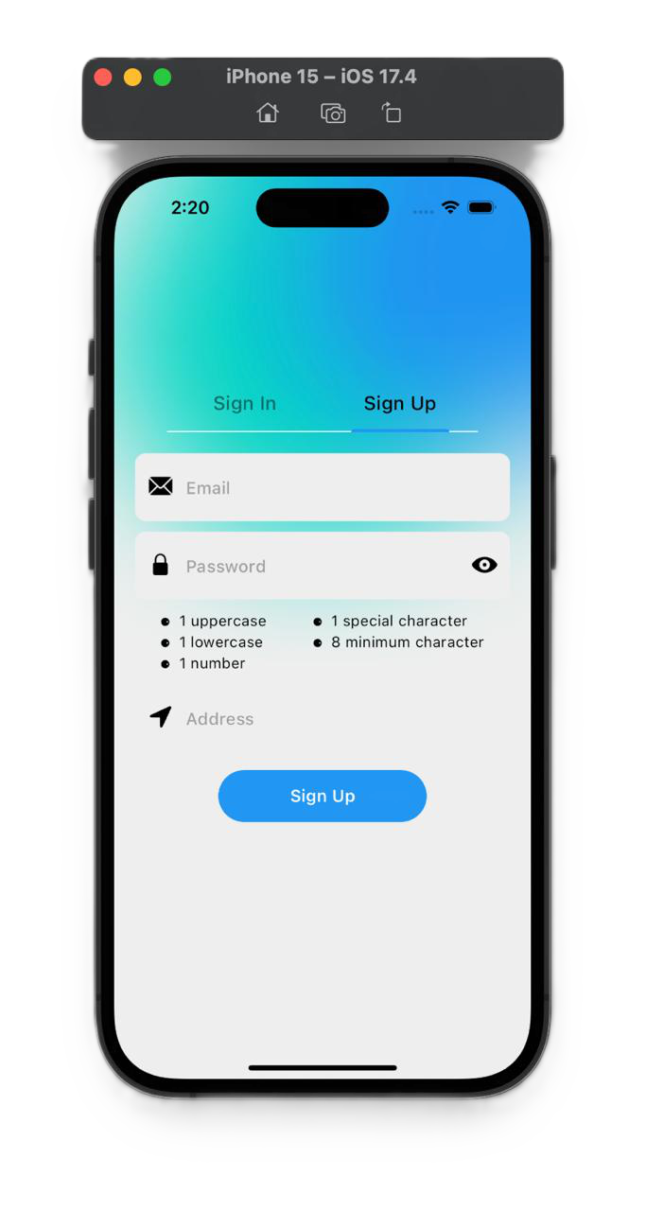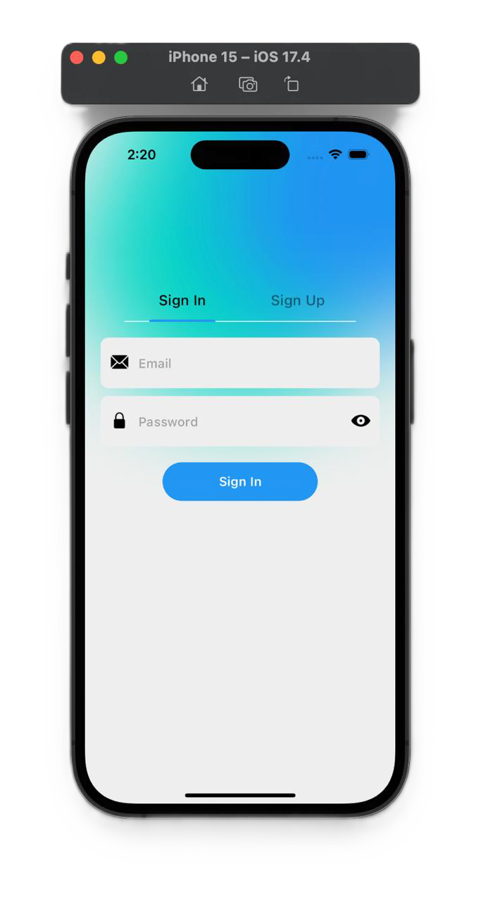

**MAIN PAGE**

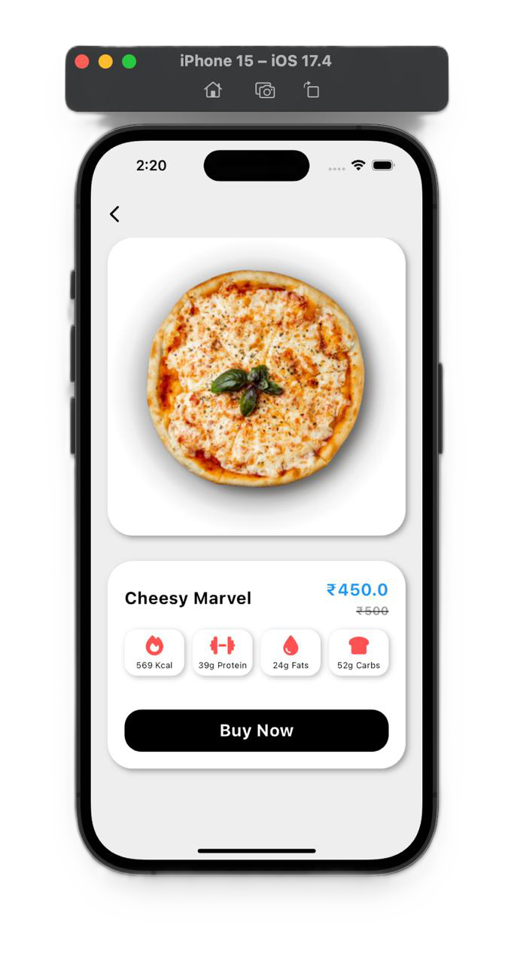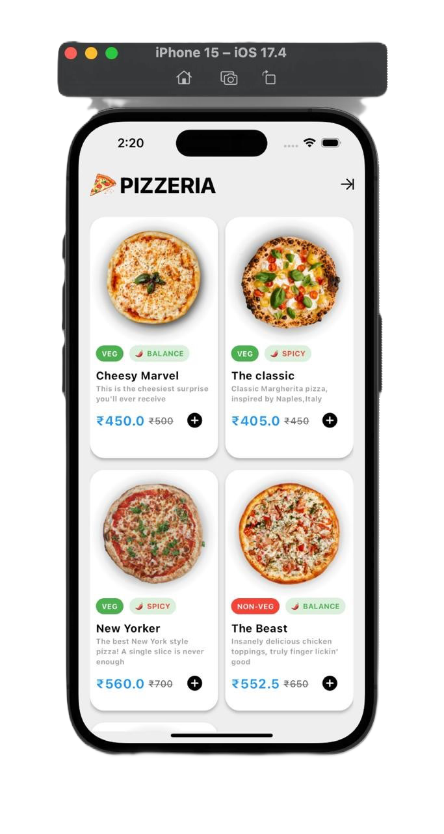

**PAYMENT INTEGRATION**

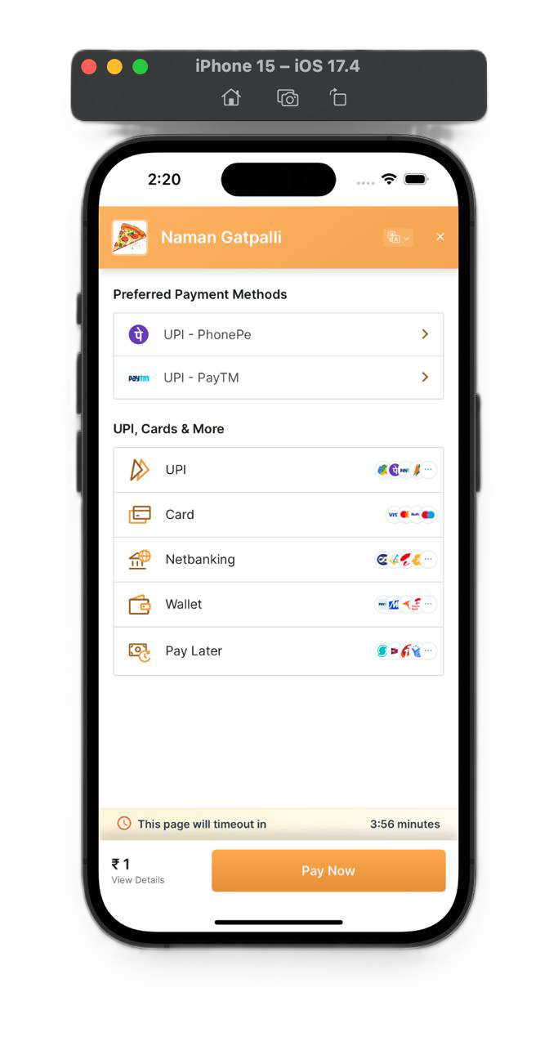

**6.1 Conclusion :**

In conclusion, the development and evaluation of the Flutter application for pizza delivery represent a significant milestone in leveraging mobile technology to enhance the food delivery experience. Through the integration of Flutter framework for cross-platform development and Firebase for authentication and database management, the project successfully delivered a robust, user-friendly, and feature-rich application tailored to the needs of pizza enthusiasts and businesses alike.

**Technological Advancements:** The project demonstrates the advancements in mobile app development enabled by frameworks like Flutter. By providing a unified codebase for iOS and Android platforms, Flutter streamlines the development process, reduces time to market, and ensures consistency across devices, thereby maximizing efficiency and cost-effectiveness.

User-Centric Design: The emphasis on user-centric design principles throughout the development process resulted in an application that prioritizes usability, intuitiveness, and accessibility. Features such as seamless navigation, clear call-to-action prompts, and personalized user experiences contribute to a positive user journey and foster user engagement and loyalty.

**Security and Reliability:** The implementation of robust security measures, including Firebase authentication and encryption protocols, underscores the commitment to safeguarding user data and ensuring secure transactions. Additionally, the application's reliability, evidenced by minimal downtime and prompt issue resolution, instills trust and confidence among users, fostering long-term relationships and brand loyalty.

**Scalability and Flexibility**: Leveraging Firebase for database management not only ensures efficient data storage and retrieval but also provides scalability and flexibility to accommodate future growth and expansion. The application's architecture is designed to scale seamlessly, enabling it to adapt to evolving user demands, technological advancements, and market dynamics.

**Continuous Improvement and Innovation:** The project's outcomes serve as a foundation for continuous improvement and innovation in the realm of food delivery applications. User feedback and performance metrics provide valuable insights into areas for refinement and enhancement, guiding iterative updates and feature additions to meet changing user preferences and market trends.

Moving forward, the success of the Flutter application for pizza delivery opens doors to further exploration and innovation in mobile app development, particularly within the food delivery industry. Future research and development efforts may focus on enhancing personalization features, expanding delivery options, integrating emerging technologies such as AI and IoT, and exploring new avenues for customer engagement and retention.

In summary, the research project underscores the transformative potential of mobile technology in revolutionizing traditional industries such as food delivery. By embracing innovation, prioritizing user experience, and leveraging cutting-edge technologies, the Flutter application for pizza delivery stands as a testament to the power of interdisciplinary collaboration and forward-thinking entrepreneurship in shaping the future of digital commerce and consumer experiences.

**6.2 Future Work**

Delivery Tracking: Implementing a delivery tracking feature in the future could significantly enhance the user experience by providing real-time updates on the status of their orders. This feature would offer users greater transparency and control over their orders, allowing them to track their pizza from preparation to delivery and estimate the time of arrival. The app could display a live map showing the delivery driver's location and route, along with notifications for key milestones such as the start of delivery and arrival at the user's location. This level of detail and visibility would not only increase customer satisfaction but also help reduce anxiety associated with waiting for their order.

AI Integration: Advancing the integration of AI within the app could further elevate the user experience by providing even more personalized recommendations and tailored services. By analyzing user behavior, preferences, and order history, AI algorithms could continuously refine and adapt recommendations to match individual tastes and dietary preferences. This might include suggesting new or popular menu items, offering promotions based on user interests, or even predicting the user's next order based on past choices. Additionally, AI could be used to optimize delivery routes and times, ensuring that orders are delivered efficiently and accurately. By continuing to leverage AI capabilities, the app could consistently improve its ability to meet and exceed user expectations.

**6.3 Applications**

**Market Expansion:** The pizza delivery app holds significant potential for market expansion into new geographical regions and customer demographics. As the app gains traction and demonstrates success in its initial launch area, there is an opportunity to scale up operations and introduce the app to other regions or even internationally. By expanding the app's footprint, the business can reach new audiences and tap into previously untapped markets, thus increasing its market share and overall customer base. This expansion could also lead to a greater variety of pizza offerings and culinary diversity, reflecting the tastes and preferences of different regions. Additionally, careful market research and tailored marketing strategies could help the app establish a strong presence in new areas and attract a diverse set of users.

**Partnerships:** Forming strategic partnerships with local pizza chains, restaurants, and delivery services can be a highly effective way to broaden the app's reach and enhance its offerings. Collaborating with established businesses in the food industry can provide users with a wider selection of pizzas and related products, as well as access to trusted, high-quality dining options. These partnerships can also facilitate efficient and timely delivery, as local businesses often have in-depth knowledge of the area and existing logistics networks. By working with local partners, the app can integrate exclusive deals, promotions, or loyalty programs that further incentivize users to engage with the app. Such collaborations not only increase the app's appeal but also foster strong relationships within the local community, paving the way for sustained growth and long-term success.